Guidelines on the Online Application for Annual Scholarship Review for International Graduate Students

(1). Please log in "my SJTU"(http://my.sjtu.edu.cn) with the jaccount and then make the application by following the instructions.
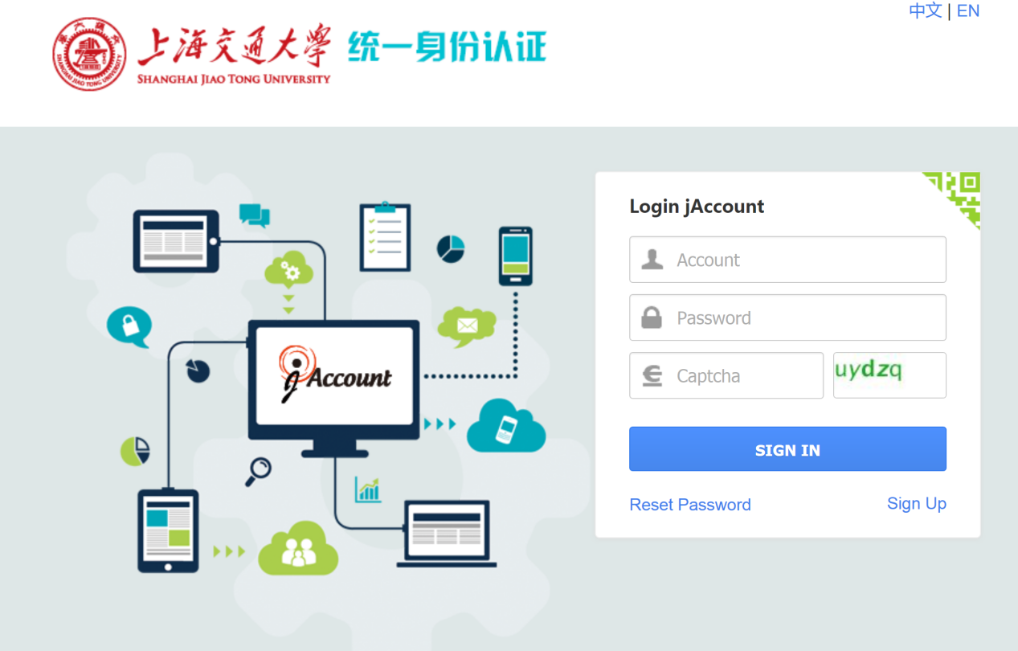

(2). Please click “Service Hall --> Postgraduates --> Annual Scholarship Review of International Graduate Students (国际研究生奖学金年度评审)”
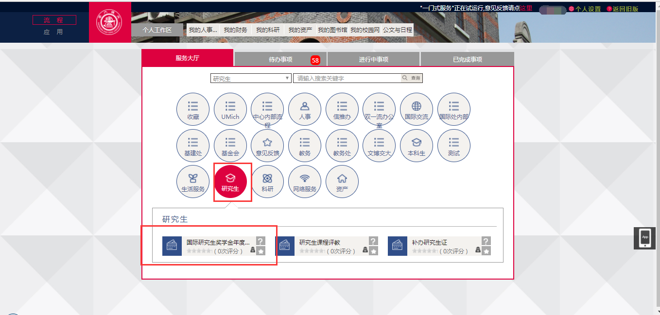

(3). Please check the personal and contact information in the table, especially the phone number and email address. If there are any mistakes, please modify them.
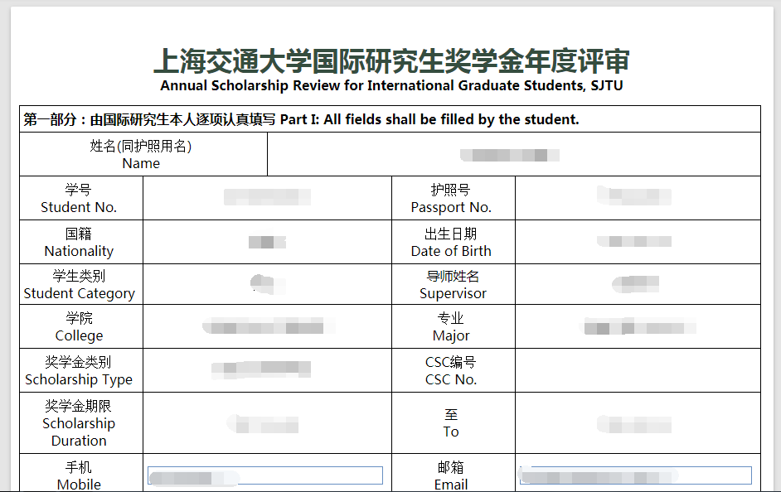

(4). Please fill in the blanks in the application.

(5). As is shown in the picture below, if you have more than one academic publication, please click “Add” to fill in other academic achievements.
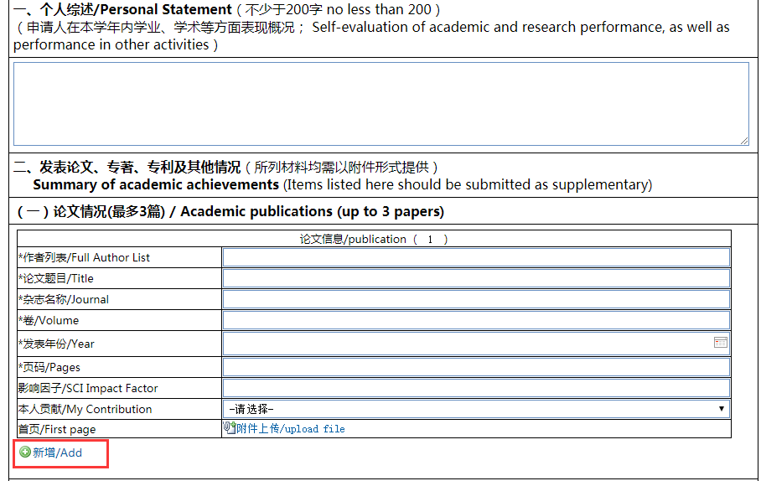
(6). When you place your cursor within the area shown as below, you will see three different icons on the right to modify the order of the academic achievements, to add and to delete it respectively. 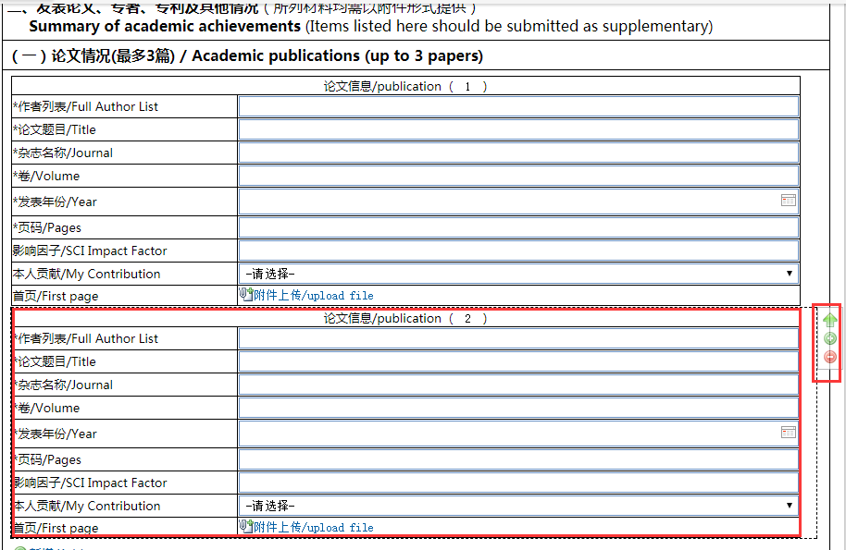

(7). After finishing the form, please click “Submit” on the top left corner.
