上海交通大学国际本科生招生考试物理科考试试卷
（样卷）
SJTU International Undergraduate Entrance Examination
(Physics sample exam papers)

- 第一部分（共20题，每小题3分。每小题只有一个正确选项）
I. Single Choice problems（3 points each）
1．哪个单位可以用基本单位表示为kgm²s⁻²？
Which unit can be expressed in base units as kgm²s⁻²?
- 焦耳 joule
- 牛顿 newton
- 帕斯卡 pascal
- 瓦特 watt
2．天然放射性元素衰变时放出的β射线是
What are the particles emitted by the spontaneous radioactive decay of an atomic nucleus during the process of beta decay?
- α粒子流
Alpha particles
- 质子流
Positrons
- 中子流
Neutrons
- 电子流
Electrons
3．如图，时钟正常工作，比较时针、分针和秒针转动的角速度和周期，秒针的
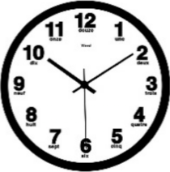
A clock works normally, Among the angular velocities and periods of hour, minute and second hands,
- 角速度最大，周期最大
Both the angular velocity and period of second hand are the largest;
- 角速度最大，周期最小
The angular velocity of second hand is the largest, while its period is the smallest;
- 角速度最小，周期最大
The angular velocity of second hand is the smallest, while its period is the largest;
- 角速度最小，周期最小
Both the angular velocity and period of second hand are the smallest.
4．如图，质量为m的物体沿倾角为α 的固定光滑斜面下滑，则物体对斜面压力的大小为
α
A frictionless pane is inclined at an angle a to the horizontal, as shown. A block of mass m is placed on the plane and allowed to slide down. The magnitude of normal force exerted on the block by the plane is
- mgsinα
- mgcosα
- mgtanα
- mgcotα
5．甲、乙两物体沿同一直线运动，右图为他们运动的s–t图，则
Two masses, a and b move along a straight line. Their dependencies of displacements on time are shown in figure. Which of the following statements is true?
s
b
a
s₀
t
t₂
t₁
O
- 甲、乙在t₂时刻相遇
They meet at time t₂;
- 甲、乙在t₁时刻相距s₀
The distance between a and b at time t₁ is s₀;
- 甲的速率小于乙的速率
The magnitude of velocity of mass a is less than that of mass b;
- 甲做减速运动、乙做加速运动
Mass a slows down while mass b speeds up.
6. 哪个图是一个负的点电荷的电场线？
Which diagram shows the pattern of the electric fied lines due to a negative point charge?

7．右图为一质点运动的v-t图像，则该质点在1s末的加速度和3s末的速度分别为
The graph shows the time dependence of velocity of a mass. Its acceleration at the end of first second and velocity at the end of third second, respectively, are
v/m⋅s⁻¹
0
2
4
2
4
t/s
- 4m/s²，4m/s
- 2m/s²，2m/s
- 2m/s²，4m/s
- 4m/s²，2m/s
8. 一个物体做简谐运动，物体的加速度是
An object moves with simple harmonic motion. The acceleration of the object is
- 常数
constant;
- 总是指向背离振动中心的方向
always directed away from the center of the oscillation;
- 在振动中心取极大值
a maximum at the center of oscillation;
- 在最远离振动中心处取极大值
a maximum at the extremes of the oscillation.
9. 长距离输电时为何使用高电压与低电流？
Why are high voltages and low currents used when electricity is transmitted over long distance?
- 电缆可与地面更近
Cables can be closer to the ground
- 电子有更加大的漂移速度
Electrons have a greater drift speed
- 减少了能量的损失
Energy losses are reduced
- 电线的电阻减少了
Resistance of the power lines is reduced
10. X和Y两容器维持同样的温度，X体积为4m³，而Y体积为6m³，它们都盛有同一种理想气体。X中的压强为100Pa，而Y中的压强为50Pa。两容器用不计体积的管子相连后，最后的压强为多少？
Two containers X and Y are maintained at the same temperature. X has volume 4m³ and Y has volume 6m³. They both hold an ideal gas. The pressure in X is 100Pa and the pressure in Y is 50Pa. The containers are then joined by a tube of negligible volume. What is the final pressure in the containers?
- 70Pa
- 75Pa
- 80Pa
- 150Pa
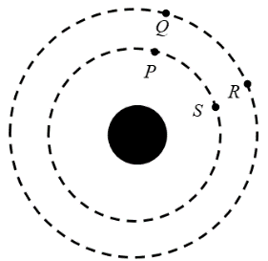
11. P 和S 是一颗行星周围引力等势面上的两点，Q 和R 是距离该颗行星更远处引力等势面上的两点，引力做的最大功是移动一个质点从
P and S are two points on a gravitational equipotential surface around a planet. Q and R are two points on a different gravitational equipotential surface at a greater distance from the planet. The greatest work done by the gravitational force is when moving a mass from
- P 到 S
P to S
- Q 到 R
Q to R
- R 到 P
R to P
- S 到 R
S to R
12. 如图所示，电压表与定值电阻相连后跨接在电压为12V的电源两端，电源内阻忽略不计，定值电阻与电压表的电阻都为20Ω，电路设计为可提供可变输出电压，输出电压的范围是多少？
The diagram shows a potentiometer and a fixed resistor connected across a 12V battery of negligible internal resistance. The fixed resistor and the potentiometer each have resistance 20Ω. The circuit is designed to provide a variable output voltage. What is the range of output voltages?
- 0-6V
- 0-12V
- 6-12V
- 12-20V
13. 两列频率为300Hz的行波叠加成驻波，驻波相邻波节间距离为1.5m。，行波的速度为多少？
Two progressive waves of frequency 300Hz superpose to produce a stationary wave in which adjacent nodes are 1.5m apart. What is the speed of the progressive waves?
- 100ms⁻¹
- 200ms⁻¹
- 450ms⁻¹
- 900ms⁻¹
14. 下图显示能量在制冷系统中是如何传递的，哪个表述解释了为何要向系统输入功？
The schematic below shows how energy is transferred in a refrigeration system. Which statement explains why work is an input into this system?
- 克服温度梯度传递热能需要做功
Work is needed to move thermal energy against a temperature gradient
- 减少传递过程中热能损失量需要做功
Work is needed to reduce the amount of thermal energy lost during transfer
- 功利用低温热库的能量去降低系统的温度
Work uses energy from the cold reservoir to reduce the temperature of the system
- 功给低温热库注入能量去增加流向高温热库的热流
Work adds energy to the cold reservoir to increase the heat flow to the hot reservoir
15. 下图显示凹面镜如何形成一个物的实像，物距离镜子20cm，而像出现在距离镜子5cm处。问镜子的焦距是多少？
The diagram below shows how a concave mirror creates a real image of an object. The object is 20cm from the mirror and the image appears at a distance of 5cm from the mirror. What is the focal length of the mirror?
- 2.5cm
- 4cm
- 25cm
- 40cm
16．一物体从某一确定高度以的速度水平抛出，已知它落地时的速度为 ，忽略空气阻力，那么它从抛出到落地的运动时间是
A mass is thrown horizontally off a building at velocity . As it touches ground, the velocity is . Assume air resistance is negligible. Time which the mass takes to reach ground is given by
17．质点以加速度a做匀变速直线运动，经过一段时间，质点的速度为v_{t}，速度的变化量为Δv，则
A particle moves in a straight line with a constant acceleration a. After some time, its velocity reaches the value v_{t} and the change of velocity is Δv. Which of the following statements is true?
- a与v_{t}方向一定相同
The directions of a and v_{t} must be the same;
- a与v_{t}方向一定相反
a must be in the opposite direction of v_{t};
- a与Δv方向一定相同
The directions of a and Δv must be the same;
- a与Δv方向一定相反
a must be in the opposite direction of Δv.
18．如图，开口向下的玻璃管竖直插在水银槽中，管内封闭了一定质量的气体，管内液面高于水银槽中液面。保持气体温度不变，缓慢地将玻璃管向下压。能描述管内气体状态变化过程的图像是（箭头表示状态的变化方向）
A glass tube is closed at one end and is immersed vertically in a big bath of mercury, as shown right. Air with certain mass is closed in the tube. At beginning, the liquid level inside the tube is higher than the level outside. Keep the air temperature constant and push the tube down. Which diagram correctly describes the change of states of air in the tube during the process (arrows in the diagrams represent the directions of the changes) ?
A
p
V
V
p
B
C
D
O
p
V
O
V
p
O
O

19．如图，水平直线表示电场中的一条电场线，A、B为电场线上的两点。一负点电荷仅在电场力作用下，从静止开始由A向B做匀加速运动。则从A到B，电场强度
Diagram shows a horizontal line representing an electric field line. A and B are the two points on the line. A point charge with negative charge begins to move from A to B with constant acceleration. Which of the following statements is true?
A
B
- 逐渐增大，方向向左
the magnitude of electric field increases from A to B and its direction is to the left;
- 保持不变，方向向左
the magnitude of electric field stays unchanged from A to B and its direction is to the left;
- 逐渐增大，方向向右
the magnitude of electric field decreases from A to B, and its direction is to the right;
- 保持不变，方向向右
the magnitude of electric field stays unchanged from A to B and its direction is to the right.
20．一列简谐横波沿x轴负方向传播，图a是t＝1 s时的波形图，图b是某振动质点的位移随时间变化的图象，则图b描述的振动图象可能是图a中位于
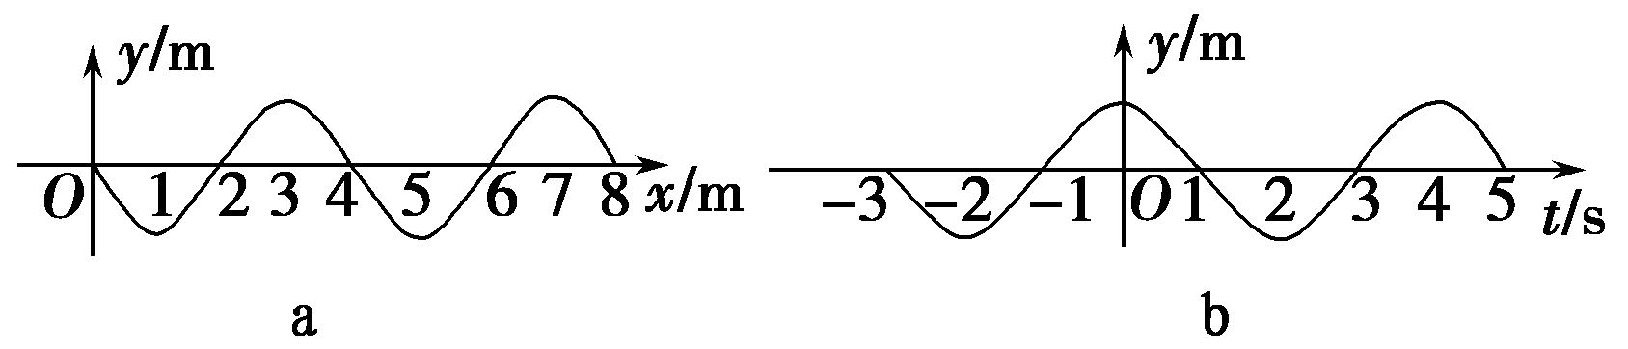
A simple harmonic transverse wave is travelling in the medium along negative x-direction. The waveform at t=1s is shown in Figure a. The time dependence of displacement of a point mass in the medium is shown in Figure b. This point mass may be located at
- x＝0处的质点
x=0;
- x＝1 m处的质点
x=1m;
- x＝2 m处的质点
x=2m;
- x＝3 m处的质点
x=3m

二、单项选择题（共10题，每小题4分。每小题只有一个正确选项）
II. Single Choice problems（4 points each）
21．如图，两端开口、粗细均匀的U形管竖直放置，用两段水银柱封闭一段气体。能使气柱变长的措施是
A U tube of uniform cross section is placed vertically, as shown in diagram. Air is closed in the tube by two mercury columns. To increase the length of air column, we should
- 增大外界气压
increase the air pressure of surroundings;
- 减小外界气压
decrease the air pressure of surroundings;
- 在U形管的左管滴入水银
add mercury into the left-hand side of U tube;
- 在U形管的右管滴入水银
add mercury into the right-hand side of U tube.
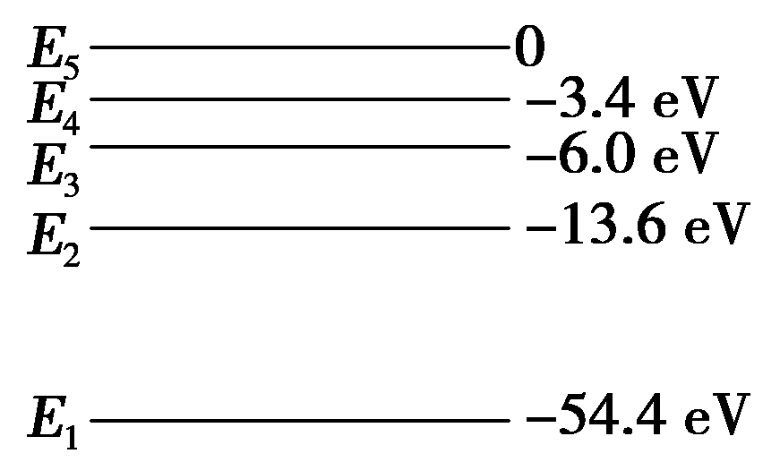
22．氦原子被电离出一个核外电子，形成类氢结构的氦离子。已知基态的氦离子能量为E₁＝－54.4 eV，氦离子的能级示意图如图，在具有下列能量的光子或者电子中，不能被基态氦离子吸收而发生跃迁的是
Singly-ionized helium (He⁺) is a hydrogen-like atom. The energy of ground state of He⁺ is E₁=-54.4eV. Its energy level diagram is shown right. Of the photon or electron with energy listed below, which can NOT be absorbed through the transition from the ground state of He⁺ ?
- 42.8 eV(光子)
photon with energy 42.8 eV;
- 43.2 eV(电子)
electron with energy 43.2 eV;
- 41.0 eV(电子)
electron with energy 41.0 eV;
- 54.4 eV(光子)
photon with energy 54.4 eV.
23．a、b和c三个带电小球，c带负电，a和b相互排斥，b和c相互吸引。则
There are three electric charges a, b and c. It is known that the charge of c is negative. a and b attract each other, while b and c repeal each other. Which of the following statements is true?
- a和b均带正电
The charges of a and b are positive;
- a和b均带负电
The charges of a and b are negative;
- a带负电，b带正电
The charge of a is negative, while the charge of b is positive;
- a带正电，b带负电
The charge of a is positive, while the charge of b is negative.
24．如图，两个共点力F₁、F₂的大小恒定。当两者的夹角θ 从60°逐渐增大到120°的过程中，合力
O
F₁
F₂
θ
Magnitudes of two concurrent forces remain constant, as shown right. With an increase of the angle θ from 60° to 120°, the magnitude of resultant force
- 逐渐增大
monotonically increases;
- 逐渐减小
monotonically decreases;
- 先增大后减小
first increases and then falls;
- 先减小后增大
first decreases and then increases.
25. 图a和图b分别表示某理想气体经历的两个循环过程；前者由甲过程（实线）和绝热过程（虚线）组成，后者由乙过程（实线）和等温过程（虚线）组成。下列说法正确的是
An ideal gas is taken through two cycles shown in Figure a and b. In Figure a, the cycle consists of process A (solid line) and adiabatic process (dash line). In figure b, the cycle consists of process B (solid line) and isothermal process (dash line). Which of the following statements is true?
- 甲、乙两过程均放热
The heats of both processes A and B are released;
- 甲、乙两过程均吸热
The heats of both processes A and B are absorbed;
- 甲过程放热，乙过程吸热
The heat of process A is released, while the heat of process B is absorbed;
- 甲过程吸热，乙过程放热
The heat of process A is absorbed, while the heat of process B is released.
26．某透镜用折射率为n=1.50的玻璃制成，它在空气中的焦距为10.0cm，则它在水（水的折射率为4/3）中的焦距为
A thin lens is made of a glass of refractive index n=1.50. Its focal length in air is 10.0cm. Its focal length in water of refractive index 4/3 is
- 10cm
- 40cm
- 30cm
- 20cm
27．氢的同位素氚核子数为3，氚核具有放射性，其发生β衰变的半衰期为12.43年。则6g氚样品经过50年后，还剩下的氚样品质量约为
The nucleon number of isotope of hydrogen, tritium, is 3. The half-life of beta decay of tritium is 12.43 years. If you start with 6 grams of tritium, how much will remain after 50 years?
- 0.3g
- 0.37g
- 0.75g
- 1.5g
28．如图，在两根平行直导线中，通以方向相反的电流I₁和I₂，且I₁>I₂，设两导线所受磁场力的大小分别为F₁和F₂，则两导线
I₁
I₂
Two parallel wires carry currents, I₁ and I₂ (I₁>I₂), which are going in the opposite direction. The forces exerted on wires 1 and 2 are F₁ and F₂, respectively. Which of the following statements is true?
- 相互吸引，且F₁>F₂
Two wires attract each other and F₁>F₂;
- 相互排斥，且F₁>F₂
Two wires repeal each other and F₁>F₂;
- 相互吸引，且F₁=F₂
Two wires attract each other and F₁=F₂;
- 相互排斥，且F₁=F₂
Two wires repeal each other and F₁=F₂.
29．如图，电源电压和a、b两灯的电阻均不变。若滑动变阻器R的滑片向左移动，则
R
b
a
In the circuit shown right, the emf and resistances of two light bulbs remain constant. If the slide piece of slide rheostat moves from right to left,
- a、b两灯均变亮
two light bulbs become brighter;
- a、b两灯均变暗
two light bulbs become darker;
- a灯变亮，b灯变暗
light bulb a becomes brighter, while light bulb b becomes darker;
- a灯变暗，b灯变亮
light bulb a becomes darker, while light bulb b becomes brighter.
30．竖直墙上a、b、c三处各有一个水平细钉子，光滑圆环如图悬挂，圆环与三个钉子均有接触。a、b、c三点中，A在圆环的最高点，c与圆环的圆心等高，则圆环受到钉子的弹力情况是
a
b
c
A frictionless circular ring is hung on three steel nails in the vertical wall, as shown right. Ring contacts with three nails. The nail a is located at the top of ring, while c is located on the same horizontal plane with the center of circle. Which nails exert elastic force on the ring?
- 可能只有a处有
Maybe only the nail a exerts a force on the ring;
- 可能只有a、b两处有
Maybe only the nails a and b exert forces on the ring;
- 一定只有b、c两处有
Certainly only the nails b and c exert forces on the ring;
- a、b、c三处一定都有
Certainly three nails exert forces on the ring.

上海交通大学国际本科生招生考试物理科考试试卷
（样卷）
参考答案

- 第一部分（共20题，每小题3分。每小题只有一个正确选项）
I. Single Choice problems（3 points each）
1、A 2、D 3、B 4、B 5、C
6、A 7、C 8、D 9、C 10、A
11、C 12、A 13、D 14、A 15、B
16、C 17、C 18、A 19、B 20、A

二、单项选择题（共10题，每小题4分。每小题只有一个正确选项）
II. Single Choice problems（4 points each）
21、B 22、A 23、A 24、B 25、C
26、B 27、B 28、D 29、D 30、A

